**Lab - Week 8: Dependency Injection, Unit Testing and Logging**

**Exercise 1 - Create a repository for students**

**Exercise 2 - Create model and service for students**

**Exercise 3 - Modify student controller**

Test the webapi with Postman as you did in week 7 to make sure it still operates as expected. Put data in the database that will trigger the setting of the "special" property to both true and false;

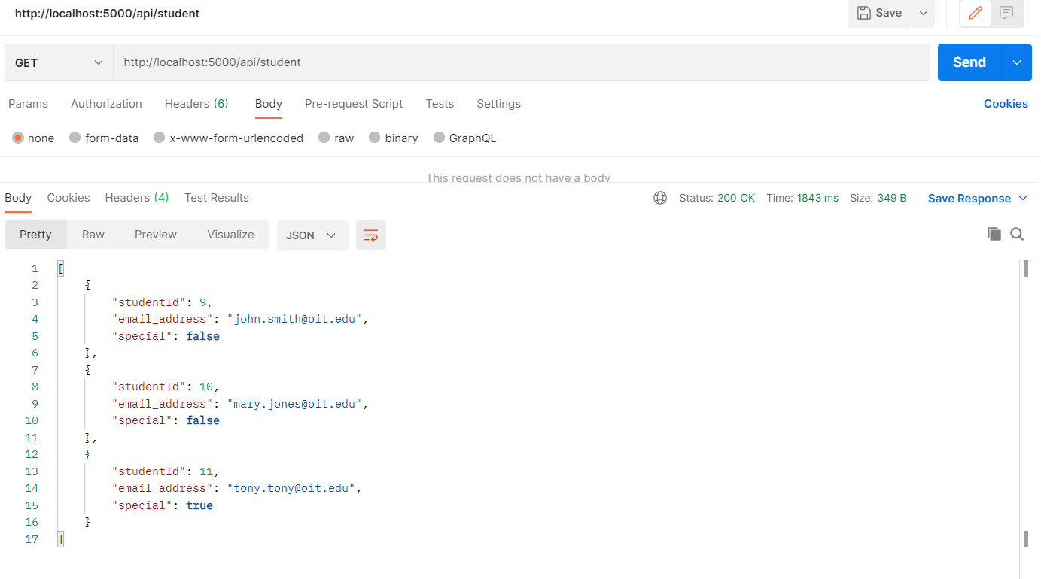

**Exercise 4 - Add unit tests**

2. Open a cmd/terminal window to the webapi.tests folder and run the following command:

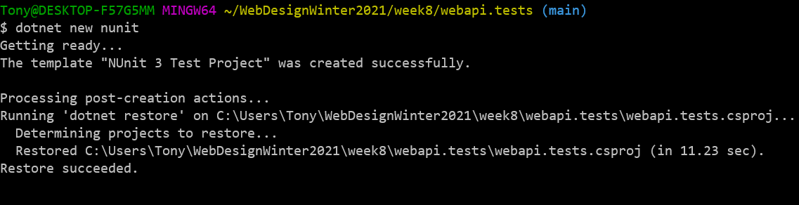

3. Run the sample test by running the following command:

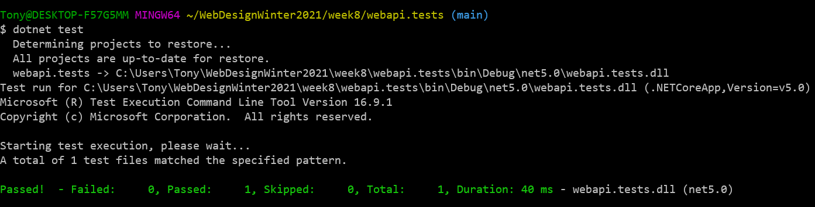

4. Install test frameworks by running the following commands:

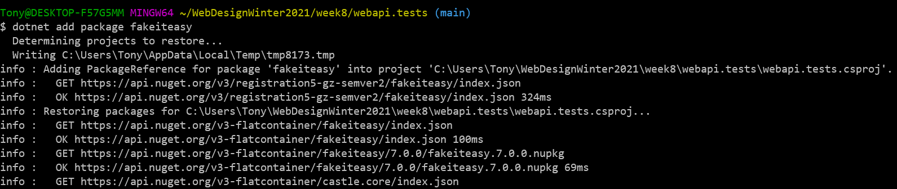

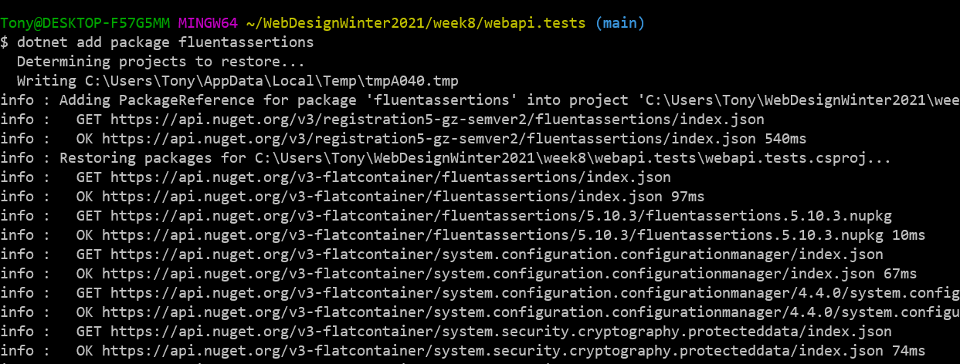

5. Reference the project under test (webapi) by running the following command:

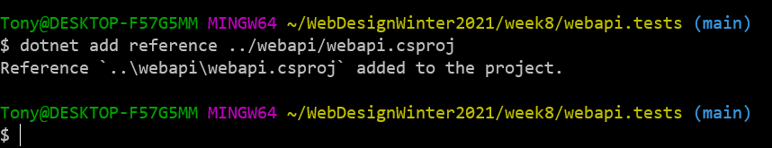

**Exercise 4 - Add unit tests**

9.Go into the StudentService class and change the criteria for determining a special student. Rerun the tests and you should see one test pass and one test fail. Go back and "correct" the StudentService class by returning to the original "business rule". Rerun the tests and you should now see both tests passing again**.**

